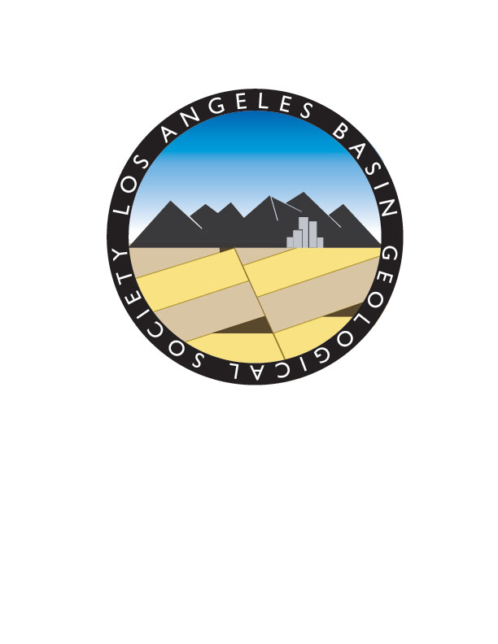

Los Angeles Basin Geological Society
Los Angeles Basin Geological Society Student Educational Scholarship
The Los Angeles Basin Geological Society (LABGS) is a non-profit professional society associated with the Pacific Section of the American Association of Petroleum Geologists (PSAAPG). Our members include geologists, hydrogeologists, geochemists and others in private industry and academia in the greater Los Angeles area. Many of our members are employed with academia, the energy industry, and the environmental industry.
In the last couple of years, LABGS has established a scholarship program in conjunction with the PSAAPG Educational Foundation. This scholarship program is to assist undergraduate and graduate students in the geological and earth sciences within our regional area with their educational needs.
This year, our scholarship program plans to award about 4-6 scholarships ranging in amounts from $500 to $1000. The awards will be based on merit and need and awarded to selected undergraduate and graduate students that meet our eligibility requirements. The awarded money must be used to advance the student’s education in geology and the related earth sciences. It may be used for tuition at a 4-year degree-granting (BS, BA, or graduate) California college or university. Scholarship funds may also be used for tuition at Summer Geology field camp, text books, and related supplies required for all students. Due to IRS rules the funds cannot be used directly for travel, room and board, research, equipment not required of all students in any particular course or program, student loan payments, or to pay clerical help.

Eligibility:
• Current student in good standing in the California public college system in LABGS sphere of influence ie. CSU-LB, F, LA, SD; UCLA, UCI etc. The sphere of influence of LABGS is Los Angeles County, Orange County, Riverside County and San Diego County.
• Student enrolled in a 4-year program leading to a BA or BS degree or in a Graduate program leading to a MS or Ph.D. degree with a student AAPG chapter or in the process of establishing a student AAPG chapter.
• Student must have a ‘B’ average or above in the geological sciences or similar.
Applications are Due to LABGS by March 31, 2025
• Applications must be filed via the internet to ktkr2@aol.com
• An official or unofficial transcript must either accompany the application or be received by LABGS – scholarship chair, by March 31st. Transcripts may be e-mailed to ktkr2@aol.com; or ‘snail’ mailed to:
Karla Tucker
18763 Fairfax Lane
Huntington Beach, CA. 92648

